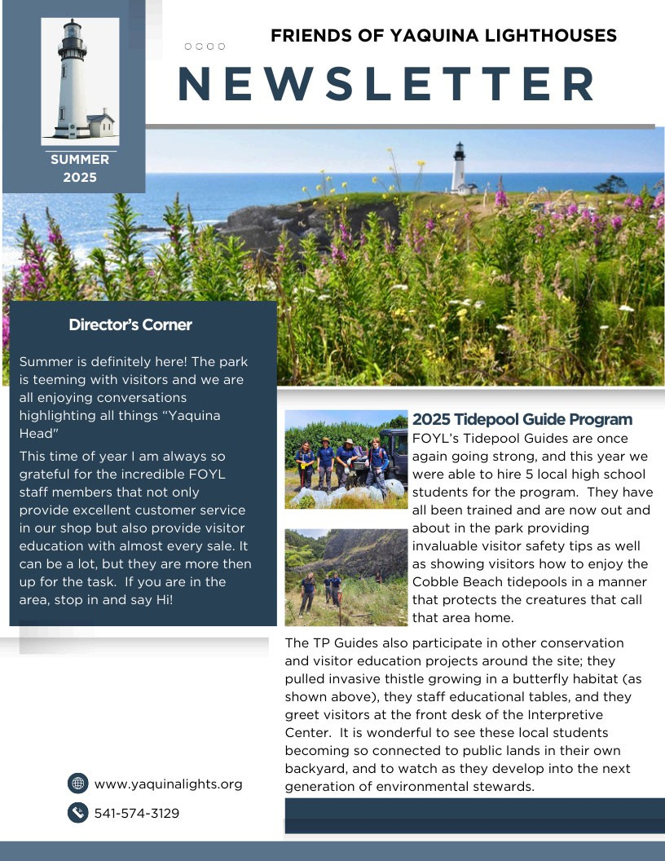

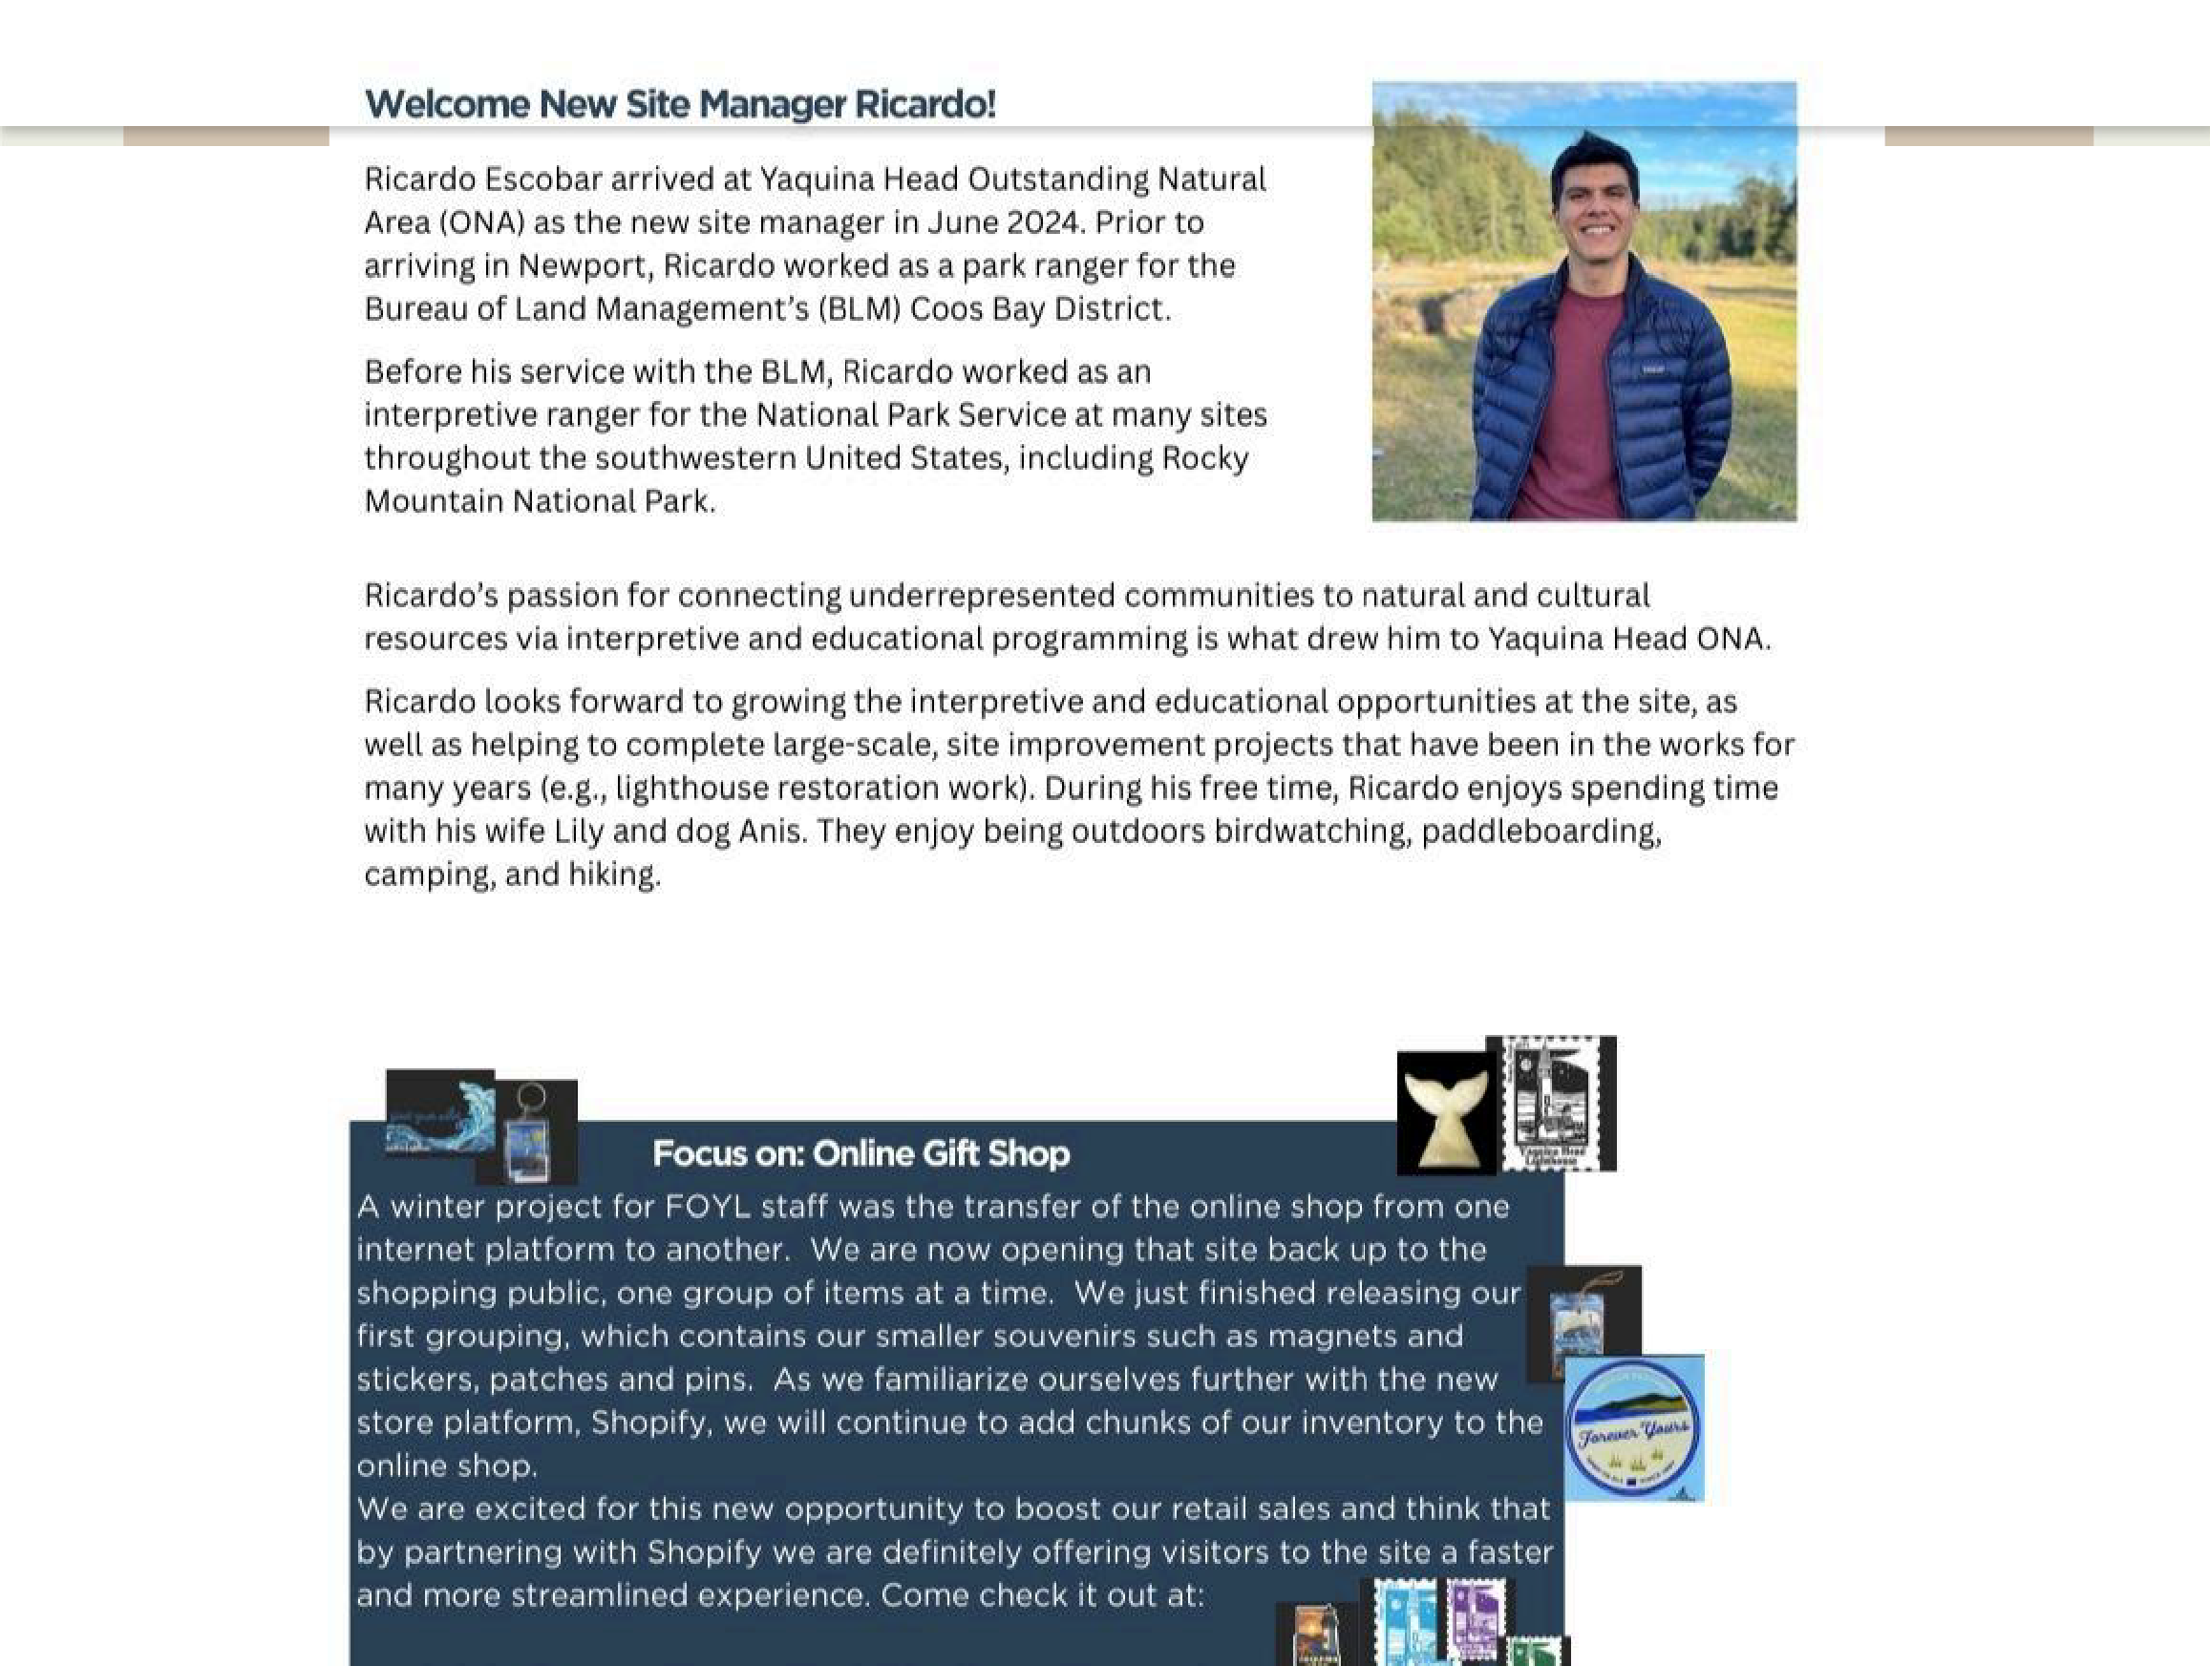

Online Shop

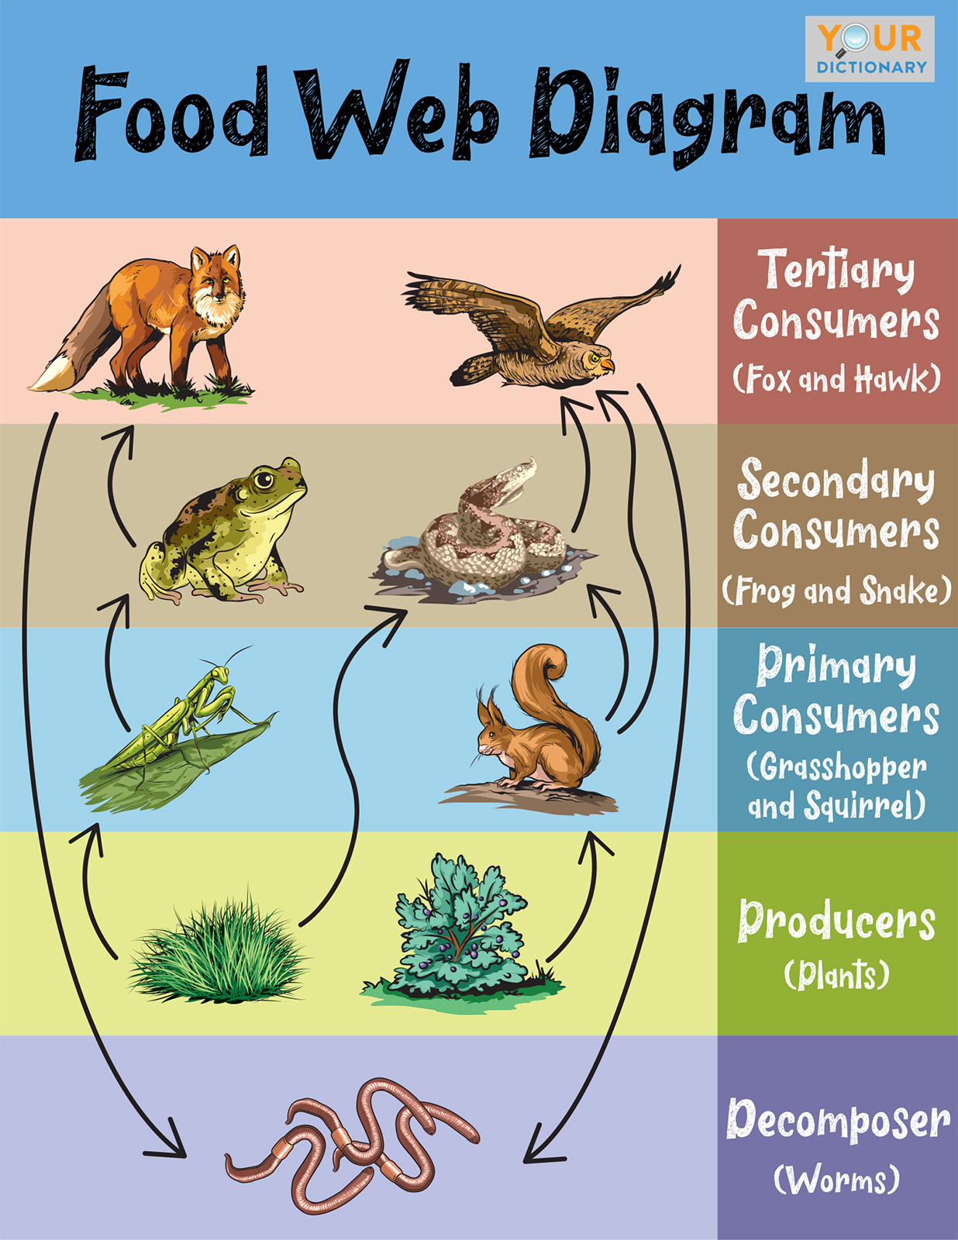

A Snapshot in Time:

The YHONA Food Web
Who lives here? On July 1 6 the Interpretive Center's Wildlife Sightings board listed mostly birds: Common Murre, Bald Eagle, Brandt's Cormorant, Brown Pelican, Harlequin Ducks, Black Oystercatcher, Tufted Puffin, Blue Heron. Harbor seals and coyote were also listed.
What about whales? In the summer we see Gray whales along the Oregon coast, often cows with calves. The best time to see Humpbacks is August and September.
Learn more at BLM YH ON A and OSU Seagrant

And then we ask, Why are they here?
Harbor seals eat fish, squid and crab. Seabirds also eat those and mussels, oysters, marine worms and more. Osprey primarily eat fish. Eagles eat fish and other birds.
Great Blue Herons and coyotes are opportunistic: they will eat a variety of insects, reptiles, amphibians, small
mammals, and birds.
As one can see, the smallest organisms have an enormous influence on the health of a habitat.
Come visit and we can add the wildlife that you spot to our board and see where it is in the YHONA Food Web.

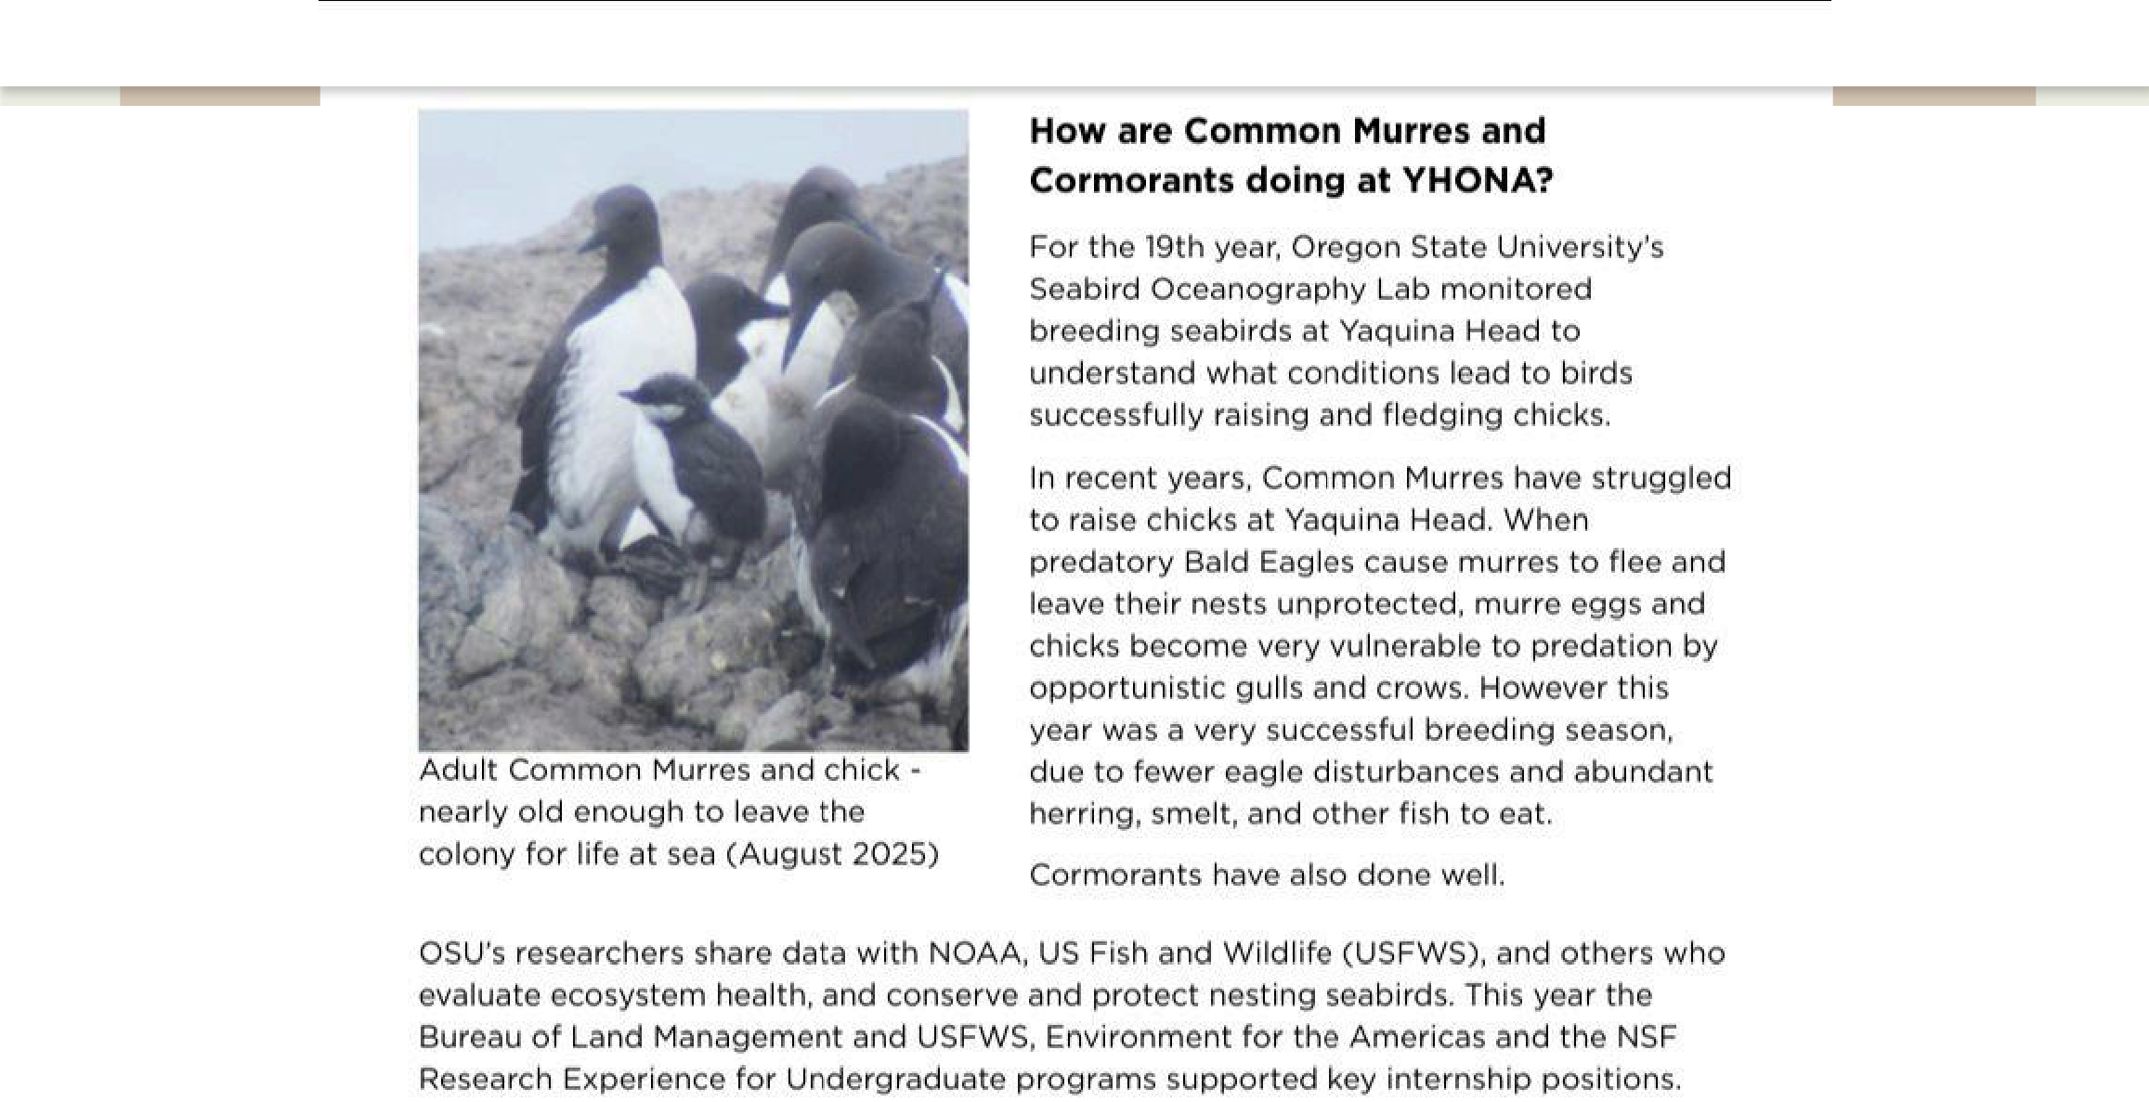


Learn more at: OSU Seabird Oceanography Authors: Will Kennerley and Rachael Orben

Upcoming Events!
Join us in celebrating

Latino Conservation Week

Caminata Oceanica 9:00 am
20 September, 2025 Entrada Es Gratis Desayuno Gratis

750 NW Lighthouse Dr, Newport, OR 97365
Please scan QR Code below to RSVP to this event

Do you have a specific topic/image you would like us to include in our next newsletter? Please submit ideas to: foyl@yaquinalights.org

Donate or Become a Member Today

